**Edureka Case Study (Boot And Package Management)**

•Let Jane check the python version if installed. If it is not installed, install python3. If installed and python2 present then remove it and then install python3.

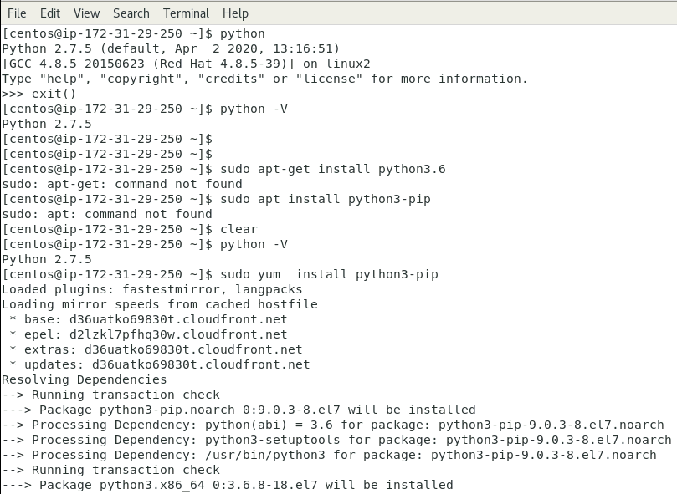

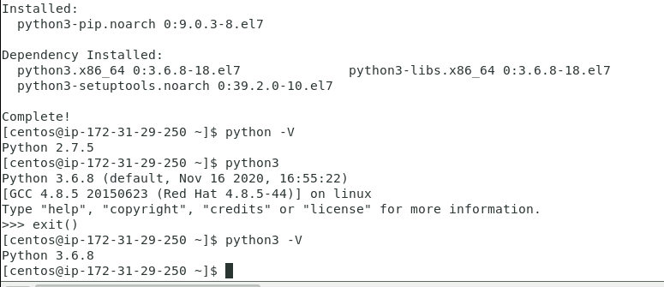

• Check if mysql is installed in either system. If not present, then install it.

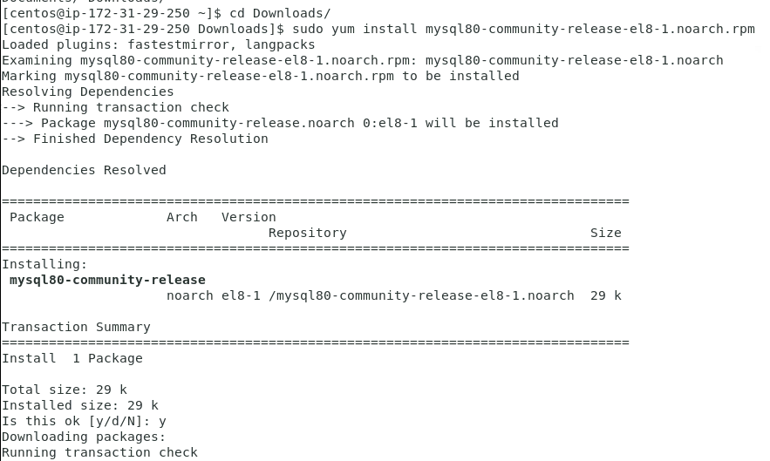

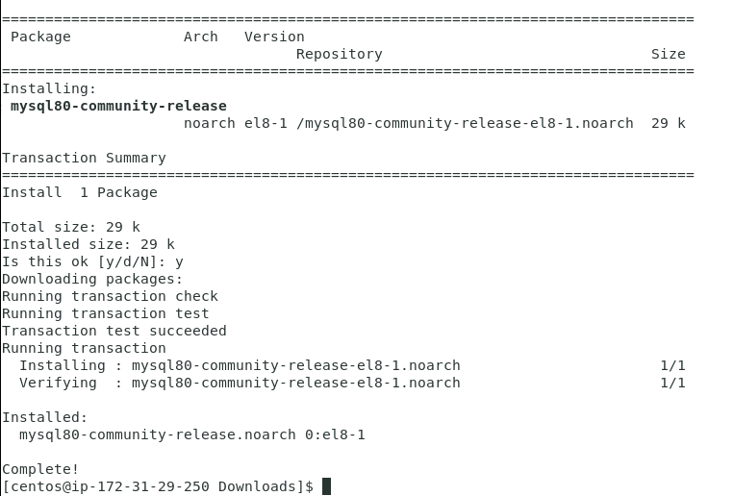

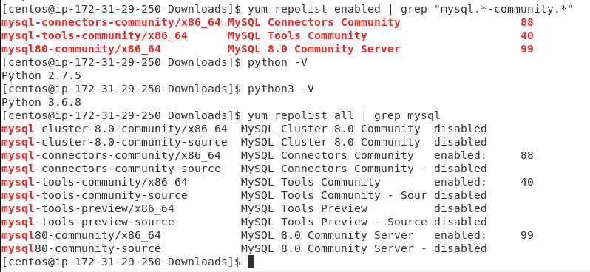

•Check if python is present in Tom’s system. If present remove it.

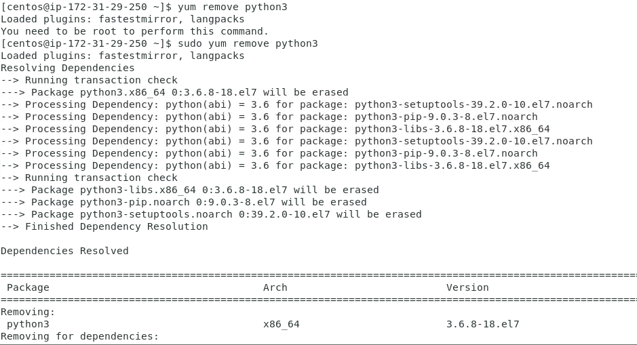

•Make sure to have sudo access or elevate the permission for the user.

•Resolve dependencies if any.

•Provide executable permission to it.

•Let java start immediately after boot.

